**A TECHNOLOGICAL APPROACH FOR COVID 19 SOLUTION**

Technologically two fold solutions can be provided for the epidemic of COVID 19. Each solution is an active solution and requires deep understanding of technology and the ever building effects to fight against the epidemic.

1. **APPLICATION FOR TRACE**: The first solution is regarding getting and identifying the Hotspots in the state which can promote spread of Covid 19 despite taking the House stay measures. The following diagram explains the flow and work of the application:

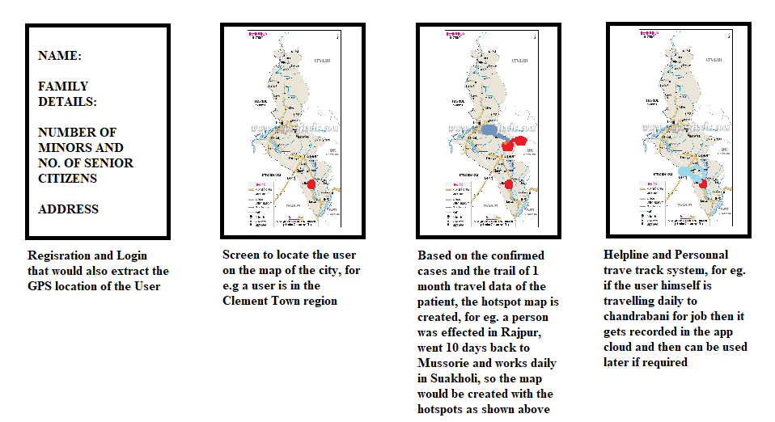

1. **TRADITIONAL SYSTEM FOR TREATEMENT:** As mentioned in the old manuscripts of India that a problem can be removed by a greater problem, so here it can be tested and developed that The COVID 19 is a Virus with three layers of proteins over it (S, M and E). The virus is not active until and unless on a host human being. Once the virus penetrates a human body, it gets active and starts replicating. One of the most dangerous problems is Malaria caused by plasmodium which unlike a virus is a unicellular organism containing a Mitochondria. Hence in order to gain energy and strengthen itself, it kills all other infections in the host body. Now if a patient of Covid 19 injected with this plasmodium, it may be treated at a later stage after getting rid of the COVID 19 virus (as cure for Malaria exists). But it requires heavy trials in enclosed laboratories before discussing. One example which puts the idea forward is that Jharkhand is a Malaria dominated state and is out of reach of COVID 19.